Day #12 - How to file your EIN?

Glad you could make it with us today, Day #12.

If you did your corporation last night, wonderful. If not, no worries, you have plenty of time.

Today we are discussing the next step in the process, EIN.

Learn what is an EIN and how to create one for your newly formed corporation.
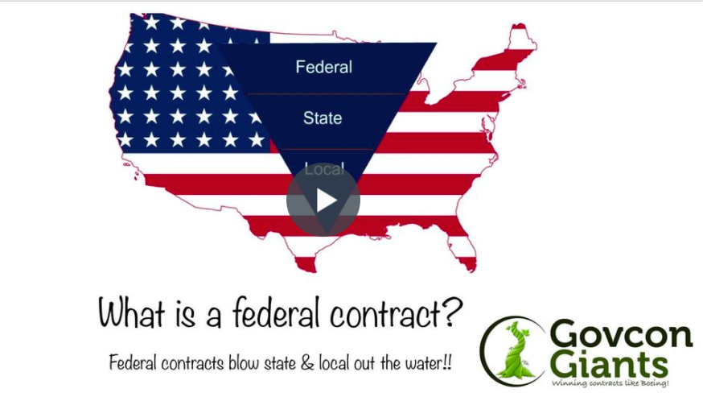

Don’t let the words IRS scare you. If you don’t do business you don’t owe any money and thus you are not require to file taxes.

Learn all the things to do so that when you have time you can do the things you have to.

Pick a name! Any name!

Big hug,

Eric Coffie

